Laporan Praktikum 2

Nama : Fakhrul Anam

Kelas : 5A

NIM : 18090113

1. Source code

Model_latihan1.php 🡪 application\models

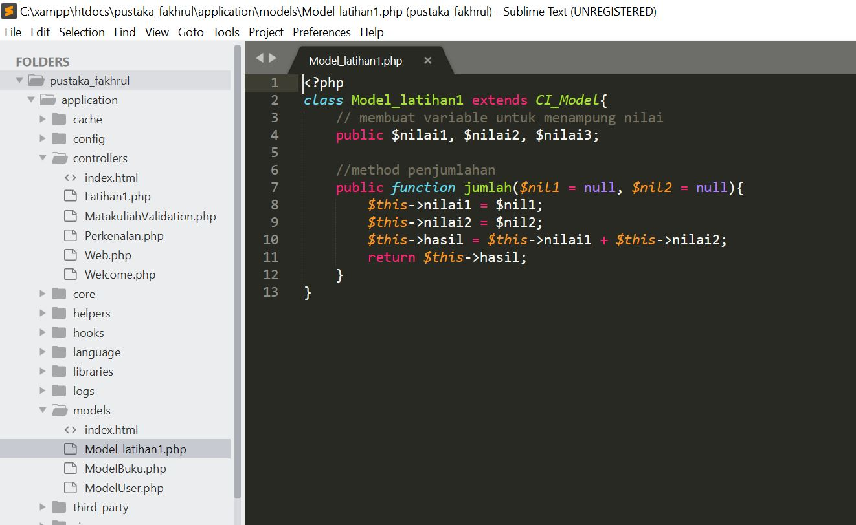

Latihan1.php 🡪 application\controllers

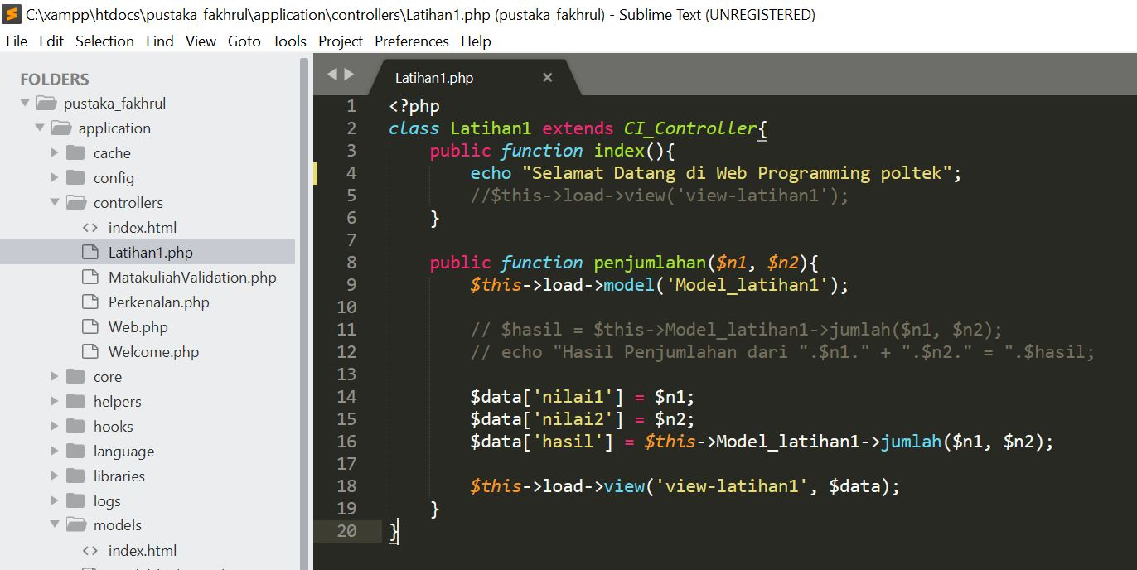

View_latihan1.php -> application\views

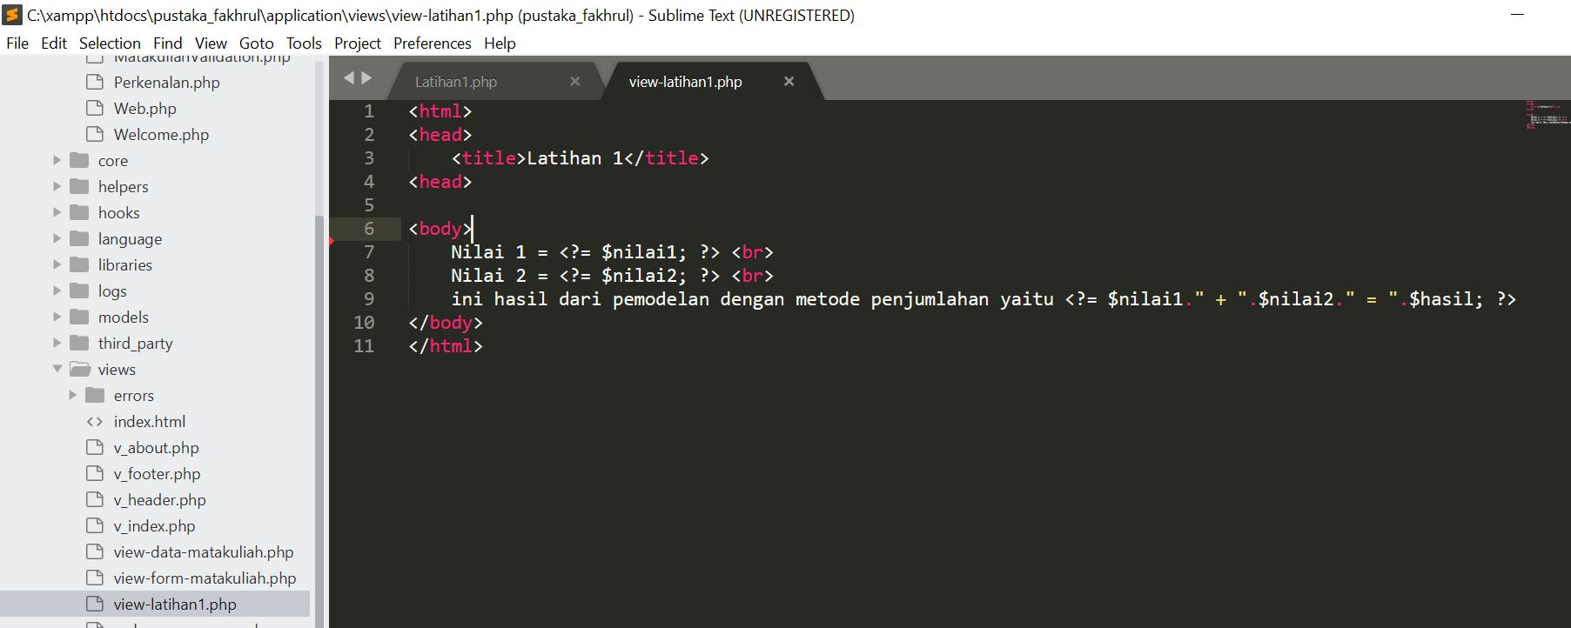

1. Capture Output Program

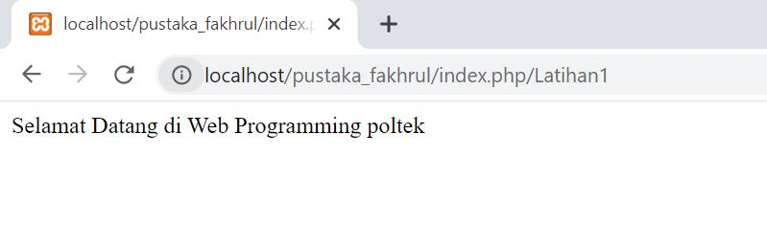  
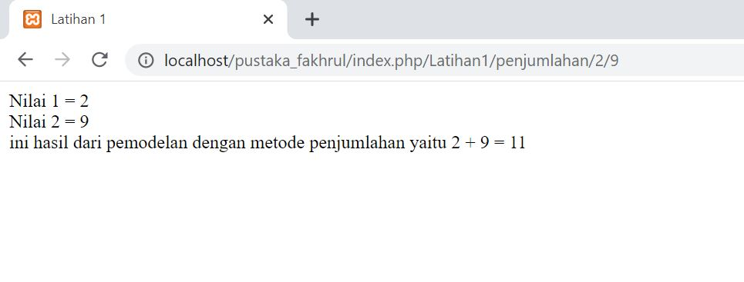

3. URL

<http://localhost/pustaka_fakhrul/index.php/Latihan1>

<http://localhost/pustaka_fakhrul/index.php/Latihan1/penjumlahan/2/9>